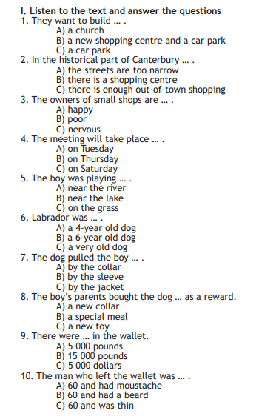
2. Use the correct phrasal verbs
1. Jamie really takes … his dad.
2. Have you taken … any new hobbies since you moved here?
3. Why don’t you turn the lights … ? It’s dark in the room.
4. We expected guests in the evening but they turned … while we were having breakfast.
5. Don’t turn … the page till I read it down.
6. Take …your coat and feel at home.
7. Don’t turn the radio … ! I’m listening to the song.
8. She turned … his offer.

3. Complete the sentences.
1. Oh, no! I…… my new phone!
a) lost ……b) have lost ……c) had lost
2. The opportunity was so good ……
a) missing … b) to miss … c) miss
3. Jon claims …… the night the crime took place.
a) to have been working … b) working … c) was working
4. It …… since last night.
a) was raining … b) rained… c) has been raining
5. Luke denied…… the vase.
a) having broken … b) to break … c) to have broken
6. John hates…… to classical music.
a) listening… b) listen … c) to listen
7. They …… English for three years now.
a) have been learning … b) have learned … c) were learning
8. Steve …… study abroad next year, but he isn`t sure.
a) must … b) can`t … c) might
9. They`re lost. They ……. know the area.
a) must… b) can`t… c) might
10. Jack …… to Spain a year ago.
a) travelled … b) was travelling … c) has travelled
11. The students …… the lesson.
a) to enjoy … b) enjoying … c) to be enjoying
12. After ……, they cut the cake.
a) to have danced … b) having danced … c) dancing
13. John …… all day and now he has a red nose.
a) has sneezed … b) has been sneezing… c) sneezed
14. It`s been years…… I rode a bike.
a) already … b) since … c) for
15. I can`t stand…… this dish.
a) eat … b) to eat …c) eating
4. Translate the sentences into English.
1) Родители Эмили развелись в 2015 году.

2)Тебя раздражает, когда кто-то сплетничает о других?

3) Моя жена уже получила повышение по службе.

4) Последней каплей было то, что Джек взял мой мобильник без разрешения.

5) Мое сердце замерло, кода лифт сломался.

6) Моего дядю уволили с работы вчера.

7) Это действует мне на нервы, когда кто-то опаздывает на встречу.

8) Мое терпение кончилось, когда Aлекс начал громко разговаривать по телефону.

9) Бабушка Дианы уже вышла на пенсию.

10) Сэм закончит университет в 2023 году.

5. Fill in the sentences with the Past Simple or Present Perfect.

1. You ever (to spend) your birthday in the USA?
2. When I was in the UK I (to meet) your friend.
3. I never (to visit) that park.
4. He (to visit) that place last year.
5. I just (to get) a letter from Tom.
6. You (to take) any photographs while travelling in the south?
7.You (to be) in Moscow last year?
8. They (to leave) England when he (to be) still a child.
9. He (not yet to come) back.
10. He (to go) already?
10. Where you (to spend) your holidays?

6.
