“WHAT DID YOU PUT IN YOUR POCKET?”
What did I put in my pocket on Monday morning? I put red in my pocket on Monday morning. I put orange in my pocket on Tuesday morning. I put yellow in my pocket on Wednesday morning. I put green in my pocket on Thursday morning. I put blue in my pocket on Friday morning. I put purple in my pocket on Saturday morning. What did I find in my pocket on Sunday morning? I found a rainbow in my pocket, a rainbow in my pocket on Sunday morning.

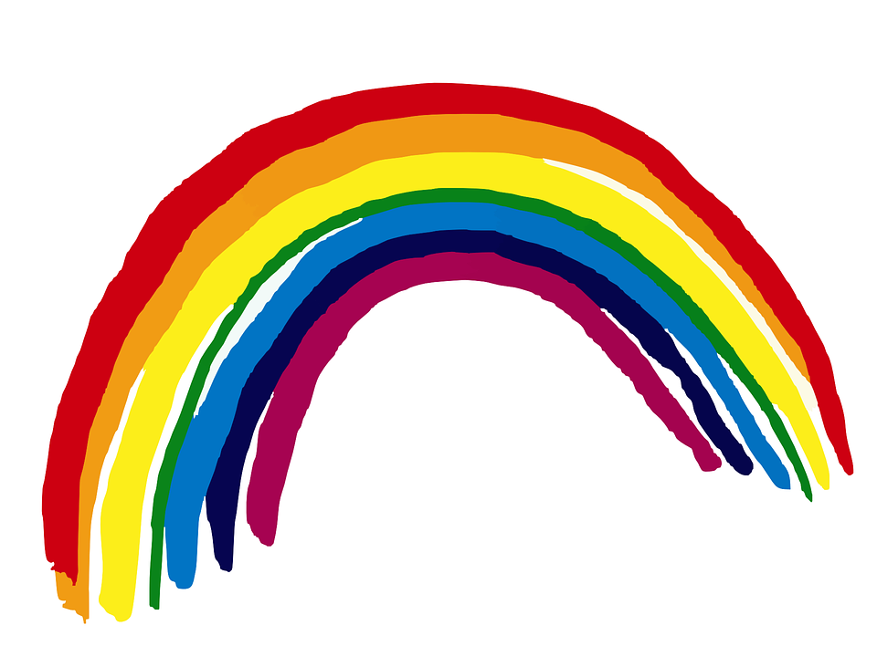

“WHAT DID YOU PUT IN YOUR POCKET?”
What did I put in my pocketon Monday morning? I put red in my pocket on Monday morning. I put orange in my pocket on Tuesday morning. I put yellow in my pocket on Wednesday morning. I put green in my pocket on Thursday morning. I put blue in my pocket on Friday morning. I put purple in my pocket on Saturday morning. What did I find in my pocket on Sunday morning? I found a rainbow in my pocket, a rainbow in my pocket on Sunday morning.
“WHAT DID YOU PUT IN YOUR POCKET?”
What did I put in my pocketon Monday morning? I put red in my pocket on Monday morning. I put orange in my pocket on Tuesday morning. I put yellow in my pocket on Wednesday morning. I put green in my pocket on Thursday morning. I put blue in my pocket on Friday morning. I put purple in my pocket on Saturday morning. What did I find in my pocket on Sunday morning? I found a rainbow in my pocket, a rainbow in my pocket on Sunday morning.

