
I want to start my speech with the proverb “Кто в Москве не бывал, красоты не видал.” It says that if you haven't seen Moscow, you haven't seen much. I believe that everyone must visit the capital of Russia. There is another proverb “The Kremlin is the heart of Moscow”. It is true because the Kremlin is the official residence of the President of Russia that is situated in the centre of Moscow. It is the main political and historical place of the city. The Kremlin has 20 towers in total. The most popular and important tower is the Spasskaya Tower, which leads to Red Square. Another world-famous landmark is also located in Red Square. Saint Basil's Cathedral is included in the list of UNESCO World Heritage Sites. It has mysterious history and tremendous facade with 11 domes. The church was built in the XVI century by order of Ivan the Terrible. Today it is open for public as a museum.
I draw the picture as if the view was taken from the roof of the house not far from Red Square. From this angle Saint Basil's Cathedral and the Spasskaya Tower looks as one sight. When I go to Moscow I want to visit Red Square but also I want to see the city from one of the roofs I think it is unforgettable experience.

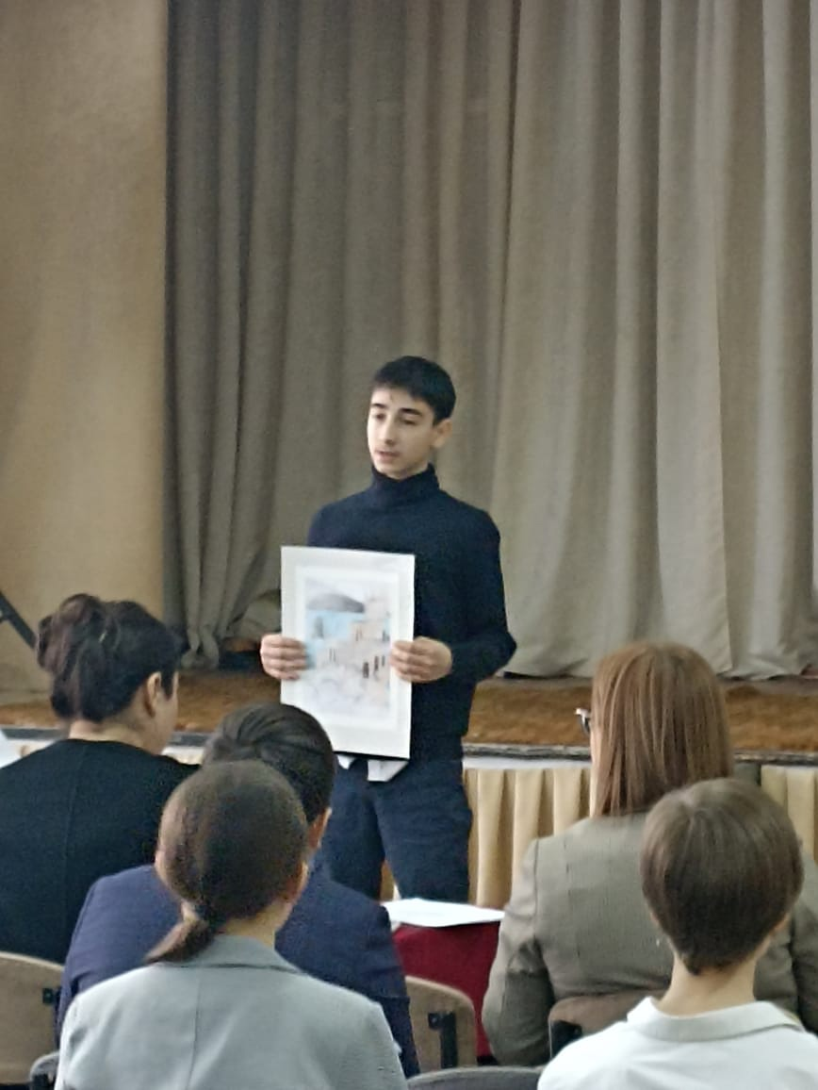
The Crimea is extremely famous for its magnificent nature, mild climate and a great number of various sights. The Swallow’s Nest is one of the most popular landmarks of the peninsula Crimea.
A wonderful architectural structure located on the edge of the Aurora cliff at Gaspra is an unspoken symbol of the Crimea. This tiny castle appeared at the end of the 19th century. There are a lot of different legends and stories about the Swallow’s Nest that makes it more mysterious and attractive. This palace appeared in some movies, for example, in “First hit” with Jacky Chan, “Ten little indians” based on the novel by Agatha Christie or “Amphibian-man”.
I have not been to the Crimea yet but I will definitely go there one day. Of course the first place I want to visit is the Swallow’s Nest. There some reasons why this place attracts me. First of all, it is a place with interesting history and many activities to do. For example, there is an art gallery in the castle and it would be nice to visit it. Also, in summer, there are shows and performances on the terrace near the castle that I want to watch. Besides, there are many restaurants with tasty food. And the last reason is of course a breathtaking view you can enjoy from the castle as it is located in a picturesque place.
Thank you for your attantion

