Name, surname____________________________________________
1.Match the types of stories to their description.
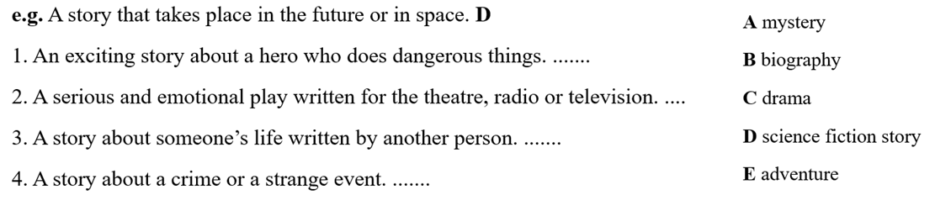
2. Write the Past Simple forms.
1. Have – 3. Decide - 5. Go –
2. Come - 4. Try - 6. Take -
3. Put the sentences in Past Simple
- Agatha Christie _______ (write) over thirty novels.
- I ___________ (lose) my wallet in the cinema.
- Miss Marple ________ (catch) many criminals.
- We ___________ (not / watch) TV last night.
- _______(Arthur Conan Doil\study)medicine at the university?
- The professor and Axel_________(find) a mysterious message.
- ___________(you/help) Ann with her homework?
- __________________(Miss Marple/live) in England?
- She_____________(not/cook dinner) last night.
- He______________(visit/his grandma) a month ago.
4. Choose the correct item:
1. I knew him as soon as/until I heard his voice.
2. He used to go fishing when/after he was a boy.
3. We played in the garden until/as soon as it got dark.
- The cat ran away as soon as/until it saw the dog
5. What did/didn’t Andy use to do when he was four?
- drink milk(√)______________________________________________
- go to the park (√) __________________________________________
- ride a bike (x) ______________________________________________
- read books (x) ______________________________________________
6. Раскройте скобки и образуйте нужную форму сложного дополнения.

- He made (I, do) it again.
- What do you want (I, tell) him?
- He tried to make (I, believe) that he was my friend.
- Her father doesn’t let (she, go) to the cinema alone.
- We watched (the children, play) in the garden.
- We heard (he, explain) something to the students.
